TINKERING PROJECT(GE107)

TITLE OF THE PROJECT:

Fingerprint based biometric system.

INFO OF TEAM MEMBERS:

GROUP-4

* Kartik Tiwari-2021csb1102
* Nakul Alawadhi-2021csb1111
* Ritesh Patil-2021csb1120
* Chaitanya Pedapudi-2021csb1121
* Akshitha Peguda-2021csb1122
* Prashant Singh-2021csb1124

BRIEF ABOUT THE PROJECT:

In this project,we are going to design a fingerprint sensor based biometric attendance system using arduino.Simply we will be interfacing fingerprint sensor with Arduino,LCD Display and RTC Module to design the desired project.In this project,we used the fingerprint module and Arduino to take and keep attendance data and records.Biometric attendance systems are commonly used systems to mark the presence in offices and schools.This project has a wide application in schools,college,business organization,offices where marking of attendance is required accurately with time.By using the fingerprint sensor,the system will become more secure for the users.

SPECIFICATIONS OF THE SOLUTION DEVELOPED:

* Arduino UNO board-1
* R305/R307 fingerprint sensor-1
* DS3231/DS1307 RTC module-1
* 16x2 LCD display-1
* Potentiometer 10K-1
* Push buttons-5
* Buzzer 5V-1
* LED 5mm any color-1
* Connecting wires
* Breadboard-1

Libraries used:

1.Adafruit_Fingerprint.h

2.EEPROM.h

3.LiquidCrystal.h

4.SoftwareSerial.h

5.Wire.h

6.RTClib.h

DETAILS OF THE CIRCUIT DIAGRAM AND ACTUAL IMAGES OF THE PROJECT:

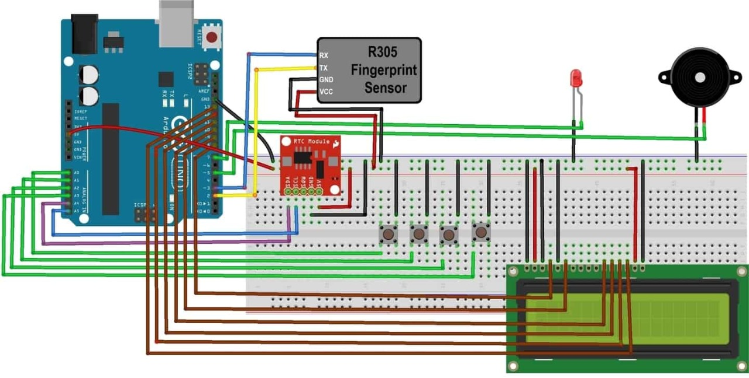

The working of the fingerprint sensor based biometric attendance system.In this project,we have used a DS3231 RTC module for time and date display.We used 1LED for power indication,and 1buzzer for different function indications.We have interfaced 16*2 LCD which displays everything whenever the finger is placed or removed,or registering attendance or downloading data.We have used 4push buttons which are used to control the entire system.The function of each button are:

1. Register/back button-used for enrolling new fingerprints as well as reversing the back process or going back.
2. Delete/ok button-this button is used for deleting the earlier stored fingerprint system as well as granting access as an OK selection.
3. Forward button-used for moving forward while selecting the memory location for storing or deleting fingerprints.
4. Backward button-used for moving backward while selecting the memory location for storing or deleting fingerprints.

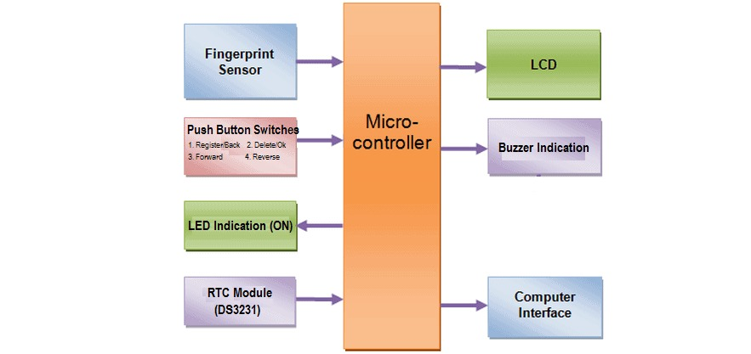

To enroll new fingerprint click on the enroll button.Then select the memory location where you want to store your fingerprint using the UP/DOWN.Then click on OK.Put your finger and remove your finger as the LCD instructs.Put your finger again.So finally your fingerprint gets stored(enrolling new fingerprint).To delete the fingerprint which is already clicked on DEL button.Then select the memory location where your fingerprint was stored earlier using the UP/DOWN button.Then click on OK.So finally your fingerprint is deleted(deleting stored fingerprint).Simply click on register/back button together.At this moment,the serial monitor should be opened(downloading data).

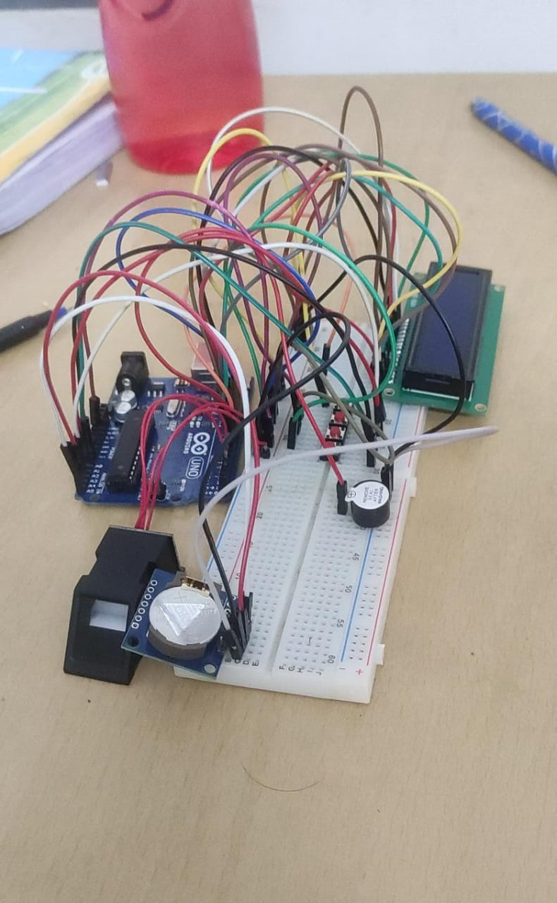

CONCLUSIONS:

In this project,we presented fingerprint based biometric attendance system using Arduino and its working idea.Since biometric attendance systems are automated user can identified or quickly and easily and also saves time.In case of biometric attendance,we canboost the security,time-effeciency,accuracy and is user friendly doesn’t need any typical passwords or smart cards.

FUTURE IMPROVEMENTS:

For faster and better fingerprint sensing GT511C3 can be used in place of R305 fingerprint.We can use facial,voice type of biometric authentication to security for accessing sensitive data.Can improve the speed of capture and minimize contact.